|  |  |  |
| --- | --- | --- |
| American University of Sharjah  College of Engineering  Department of Computer Science & Engineering  P. O. Box 26666, Sharjah, UAE |  | **Instructors:** Dr. Michel Pasquier  **Lab Instructor:** Praveena Kolli  **Office:** EB2-12  **Phone**: 971-6-5152352  **e-mail**: pkolli@aus.edu  **Semester**: Spring 2021 |

**CMP305L - Data Structures and Algorithms Lab**

**Lab. Assignment 10 – Trees and Binary Trees**

***Objectives***

* To understand Trees and Binary Trees
* To implement recursive traversals on trees

***Instructions***

* Do not use any static or global variable. Use recursion!

***Note:***

***Lab:*** Exercises 1 and 2 (10 marks)

***Bonus*:** Exercise 3 (1 mark)

***Exercise 1:***

Write the following recursive functions that work on a general tree. The *TreeNode* structure is provided to you.

1. Depth of a node: that is the number of edges from the tree's root node to that node.
2. Height of a node: that is the number of edges on the longest downward path from that node to a leaf node.

You may use the provided main() function to continue creating nodes and the tree structure so as to test the above functions.

Code:

#include<iostream>

using namespace std;

template <typename Object>

struct TreeNode

{

Object element;

TreeNode *firstChild;

TreeNode *nextSibling;

TreeNode(const Object & e = Object{ }, TreeNode * first = nullptr, TreeNode * next = nullptr)

: element{ e }, firstChild{ first }, nextSibling{next}{ }

};

template <typename Object>

int depth(TreeNode<Object>* root, TreeNode<Object>* node, int dep = 0) {

if (root == node) return dep;

if (root == nullptr) return 0;

int dep1 = 0, dep2 = 0;

if (root->nextSibling != nullptr) {

dep1 = depth(root->nextSibling, node, dep);

}

if (root->firstChild != nullptr) {

dep2 = depth(root->firstChild, node, dep + 1);

}

if (dep1 > dep2) return dep1;

else return dep2;

}

template <typename Object>

int height(TreeNode<Object> *node, int d=0)

{

if(node->firstChild != nullptr)

{

if(node->nextSibling == nullptr)

return height(node->firstChild, d + 1);

else

{

int hSibling = height(node->nextSibling, d), hChild = height( node->firstChild, d + 1);

return (hSibling > hChild) ? hSibling : hChild;

}

}

else

{

if(node->nextSibling == nullptr)

return d;

else

return height(node->nextSibling, d);

}

}

int main()

{

TreeNode<char> *root = new TreeNode<char>('A', nullptr,nullptr);

TreeNode<char> *b = new TreeNode<char>('B', nullptr, nullptr);

TreeNode<char> *c = new TreeNode<char>('C', nullptr, nullptr);

TreeNode<char> *d = new TreeNode<char>('D', nullptr, nullptr);

TreeNode<char> *e = new TreeNode<char>('E', nullptr, nullptr);

TreeNode<char> *f = new TreeNode<char>('F', nullptr, nullptr);

TreeNode<char> *g = new TreeNode<char>('G', nullptr, nullptr);

TreeNode<char> *h = new TreeNode<char>('H', nullptr, nullptr);

TreeNode<char> *i = new TreeNode<char>('I', nullptr, nullptr);

TreeNode<char> *j = new TreeNode<char>('J', nullptr, nullptr);

TreeNode<char> *k = new TreeNode<char>('K', nullptr, nullptr);

TreeNode<char> *l = new TreeNode<char>('L', nullptr, nullptr);

TreeNode<char> *m = new TreeNode<char>('M', nullptr, nullptr);

TreeNode<char> *n = new TreeNode<char>('N', nullptr, nullptr);

TreeNode<char> *o = new TreeNode<char>('O', nullptr, nullptr);

TreeNode<char> *p = new TreeNode<char>('P', nullptr, nullptr);

TreeNode<char> *q = new TreeNode<char>('Q', nullptr, nullptr);

root->firstChild = b;

b->nextSibling = c;

c->nextSibling = d;

d->firstChild = h;

d->nextSibling = e;

e->firstChild = i;

e->nextSibling = f;

f->firstChild = k;

f->nextSibling = g;

g->nextSibling = n;

n->firstChild = o;

o->nextSibling = p;

o->firstChild = q;

cout << "The height of the tree is: " << height(root) << endl;

cout << "The depth of node Q is: " << depth(root, q) << endl;

cout << "The depth of node O is: " << depth(root, o) << endl;

cout << "The depth of node D is: " << depth(root, d) << endl;

cout << "The depth of node A is: " << depth(root, root) << endl;

}

The tree looks like:

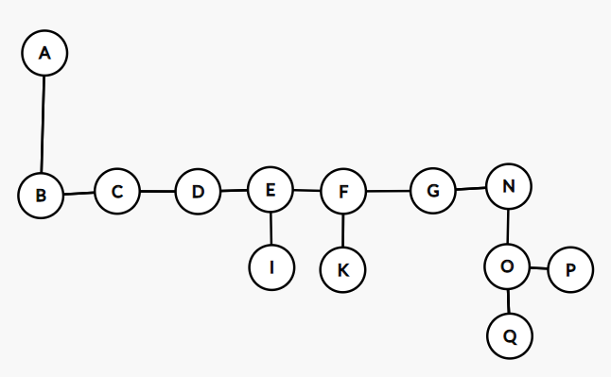

Screenshot:

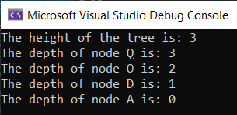

***Exercise 2:***

Write the following recursive functions that work on a binary tree. The*BinaryNode*structure is provided to you in appendix. The function *MakeTree* is also given, which takes an algebraic expression as string and creates a matching tree representation.

1. A function that prints the tree in *Infix* equivalent format (cf. example hereafter):

template <typename Object>

void inFix(BinaryNode<Object>* node)

1. A function that prints the tree in *Postfix* equivalent format (cf. example hereafter):

template <typename Object>

void postFix(BinaryNode<Object>* node)

1. A Function that prints the tree in *Prefix* equivalent format (cf. example hereafter):

template <typename Object>

void preFix(BinaryNode<Object>* node)

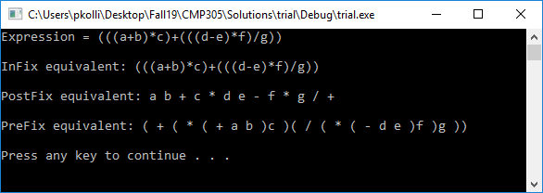

You should use the provided main() to test the three functions.

***Bonus:***

***Exercise 3:***

In the Array-based implementation of Binary Tree, the left child of the node at index i is at index (2*i + 1) and the right child of the node at index (2*i+ 2). The parent of the node at index i is at index ((i-1)/2).

Write the following functions,

1. Construct a binary tree from the given array

template <typename Object>

void ArrayToTree(BinaryNode<Object> *&tree, Object arr[], int size, int startIndex)

1. Construct an array from the given binary tree

template <typename Object>

void treeToArray(BinaryNode<Object>* tree, Object values[], int& index)